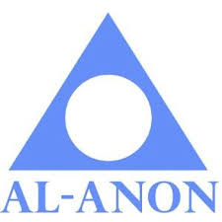

Speaker Meeting
With Patti N from the Morning Hope AFG

Brant Hills Al Anon Family Group - Burlington
Wednesday, April 29th, 2020
7:30 – 8:30pm

Wellington Square United Church
2121 Caroline Street
Burlington

