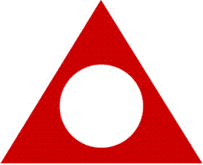
HAMILTON BURLINGTON
ALATEEN MEETING
Every Thursday at 7PM
Unitarian Church
170 Dundurn St. S.
Hamilton
Enter using Main door off parking lot
Starting
Thursday November 4th, 2021

For more information contact
Rita B.
District 14 Alateen Coordinator
289-700-2093

Covid-19 Health Safety Guidelines in effect

